**EXECUTION FLOW OF PROJECT**

**1.Running code on eclipse**

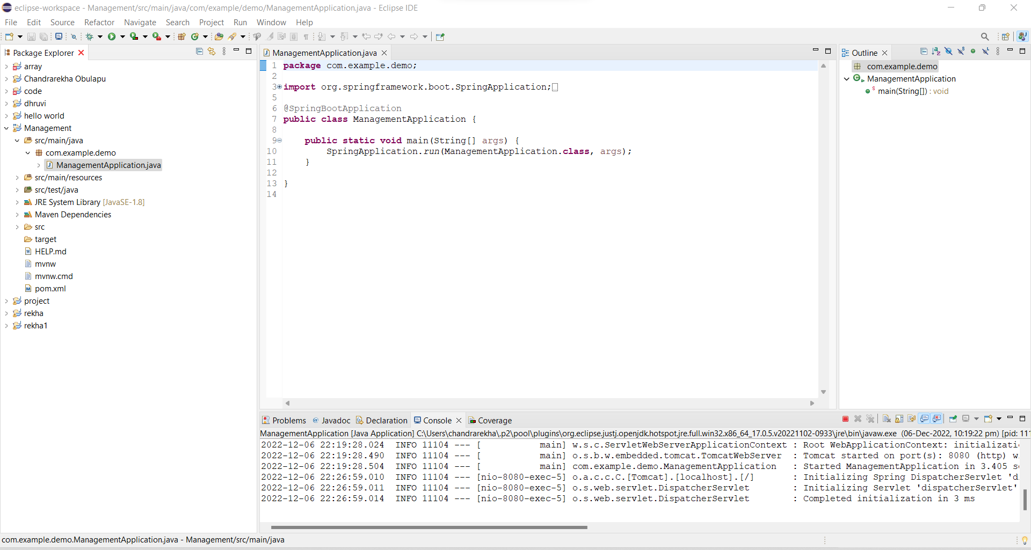

**2.Displays Login page after running the code on eclipse.**

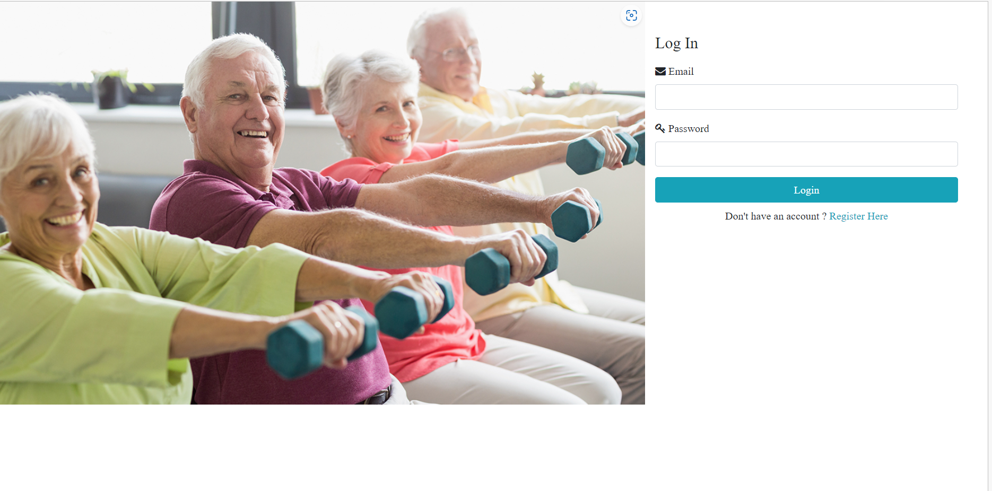

**3.This is the empty registration page.**

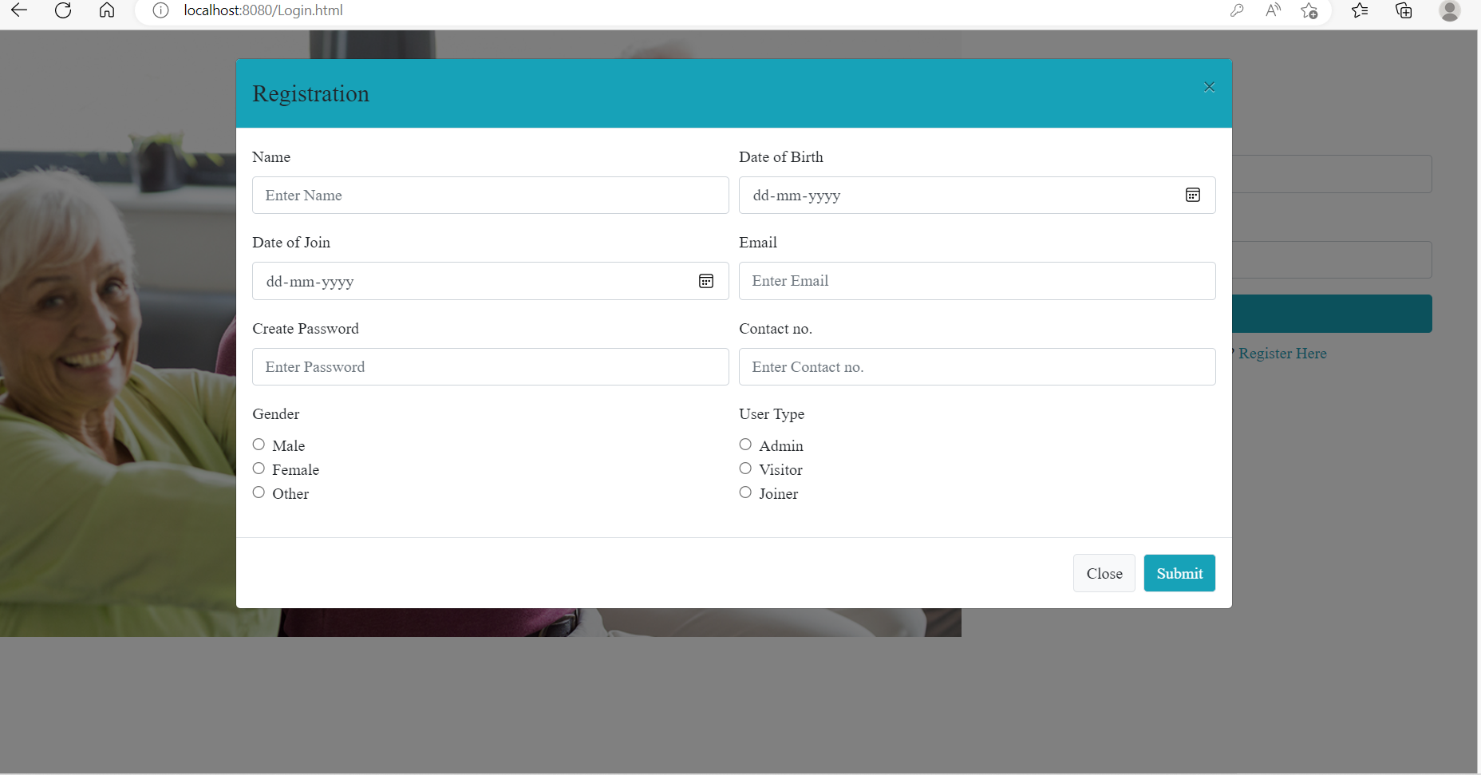

**4.The registration page is filled with the user details.**

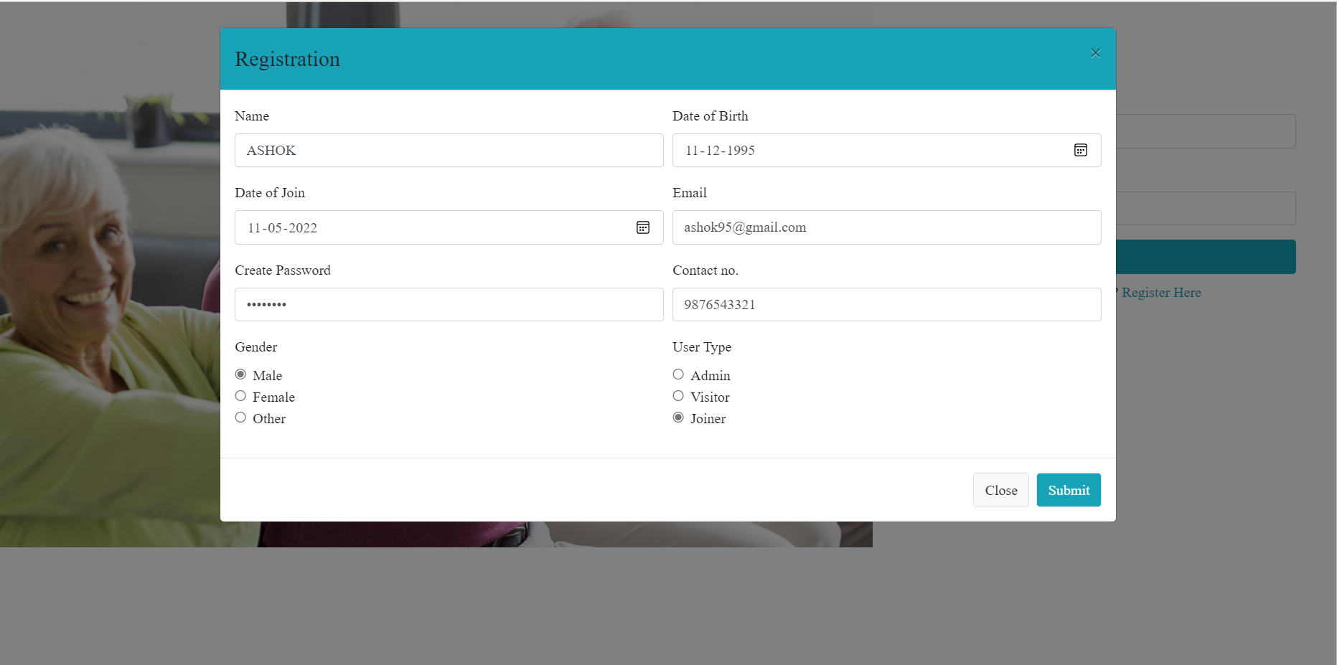

**5.After giving the details the page shows registered successfully.**

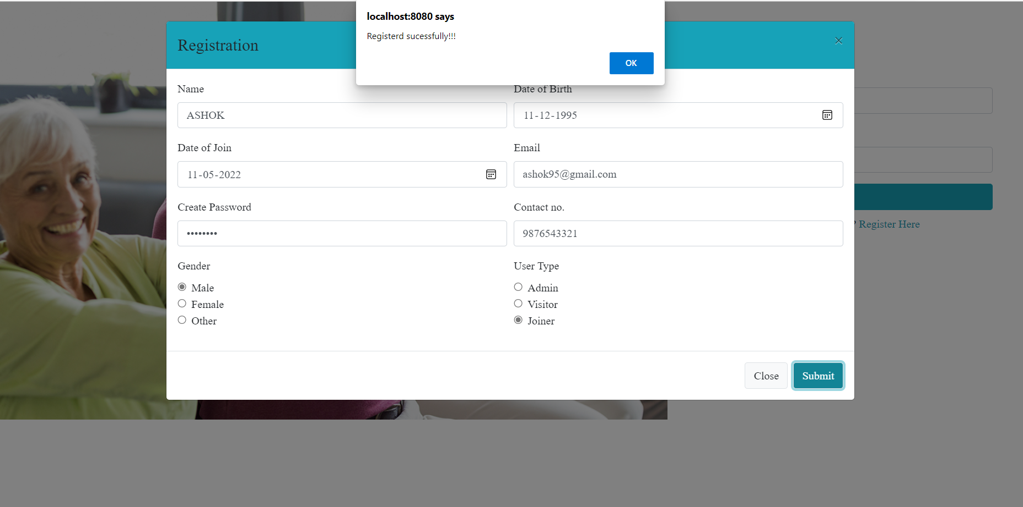

**6.And then it displays Services and History of the senior citizen people.**

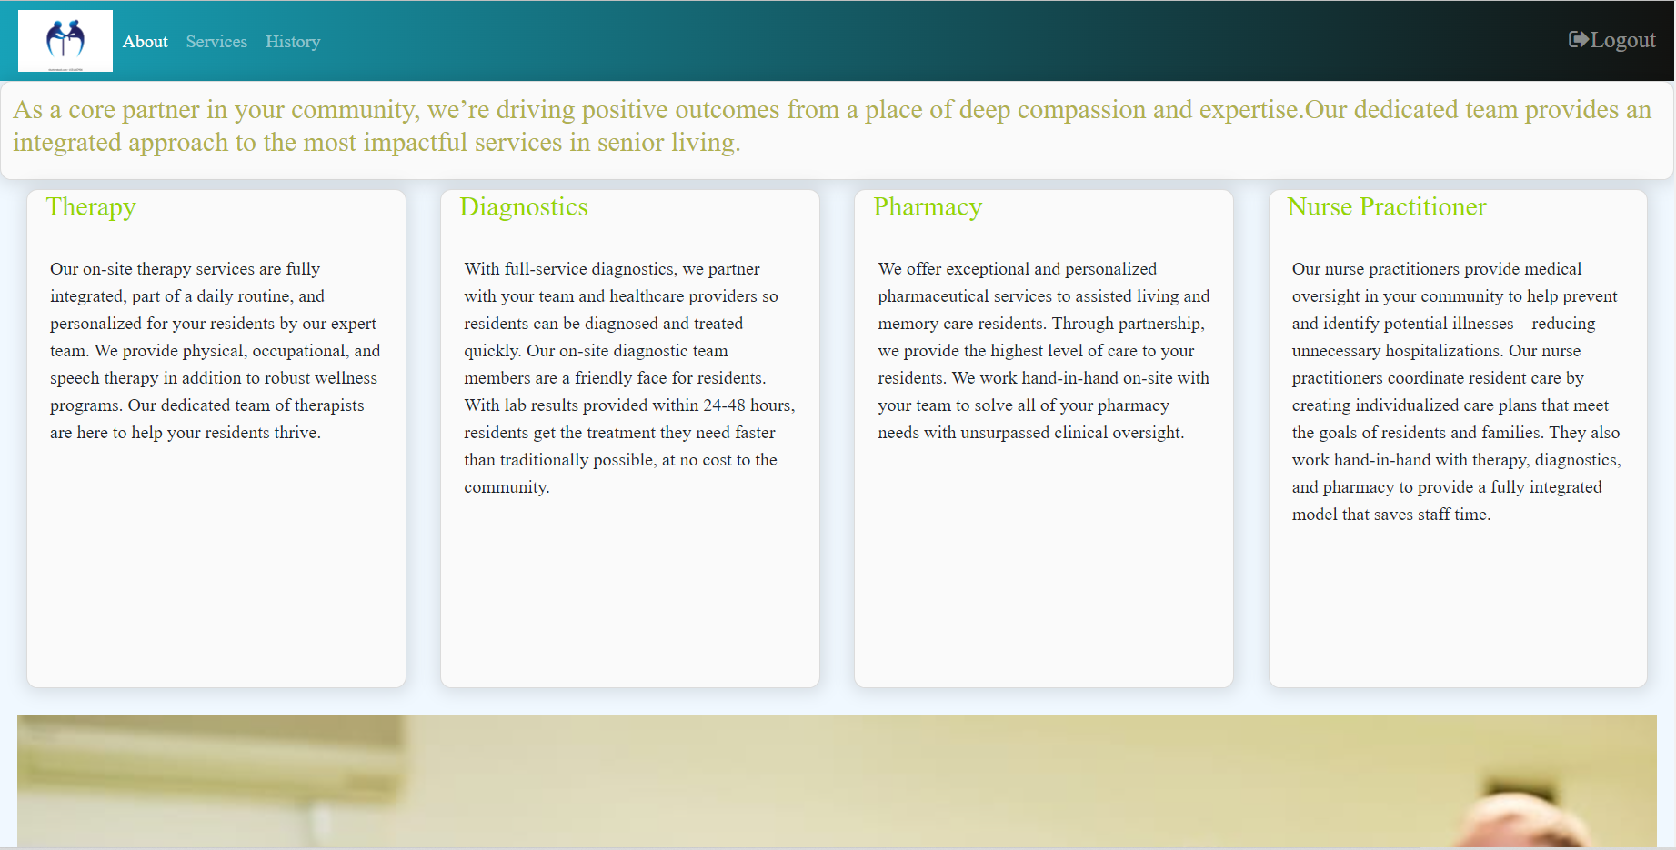

**7.In the services we have to give the details and then after giving the payment option then this data will be stored in the History**

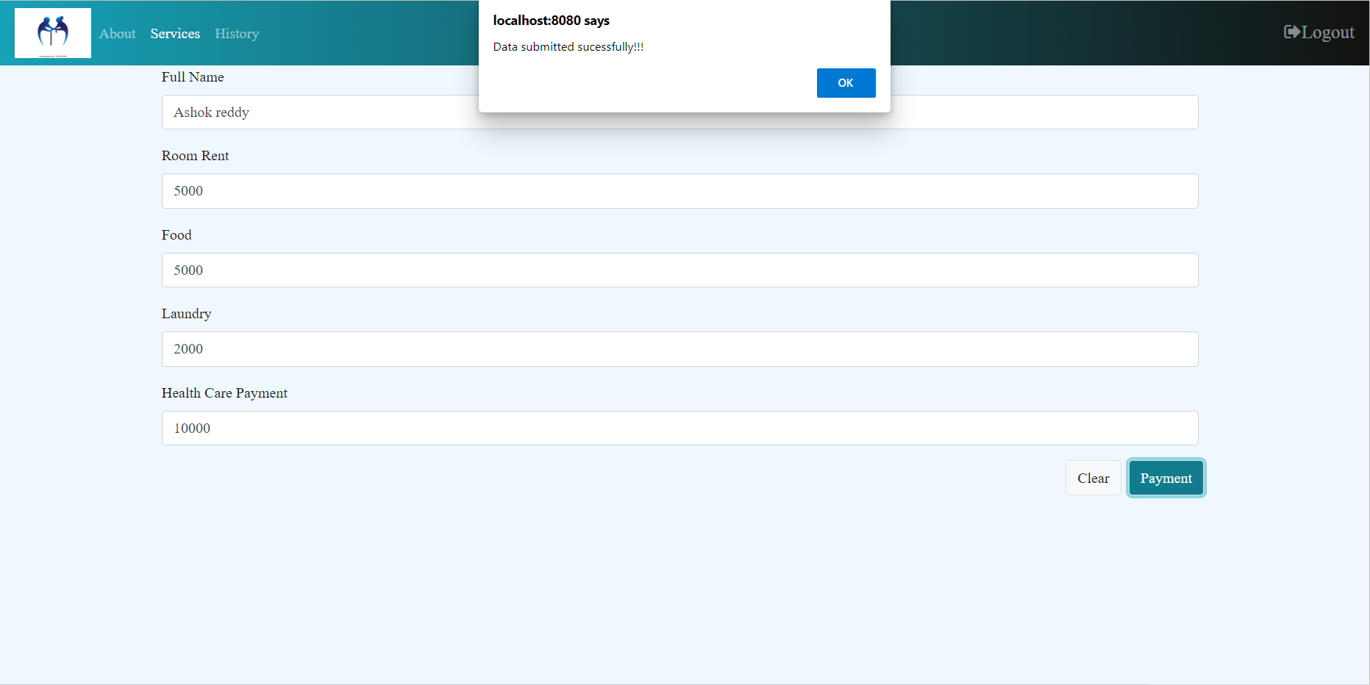

**8.In the History the data will be stored.**

